What does the Census tell us about our Local Area?
Unheard Histories
STEP
6

STEP
1

STEP
2

STEP
4

What was the impact of World War II on the people of Britain?
How am I Making History?

STEP
5

Step
R

STEP
3

Step 1-9
History LTP
Were the Vikings Raiders, Traders or Settlers?

How did the Maya Civilisation compare to the Anglo-Saxon?
What was life like in Tudor England?
How hard was it to invade and settle in Britain?
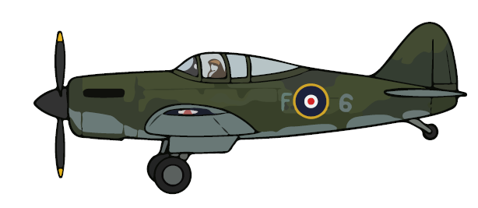
What did Ancient Egyptians believe?

How have Children’s lives changed?
Would you prefer to live in the Stone Age, Bronze Age or Iron Age?

How was School different in the past?

Why did the Romans settle in Britain?
What is a Monarch?
How did we learn to fly?

What did the Greeks do for us? Who were the Ancient Greeks?
How have Explorers changed the world?
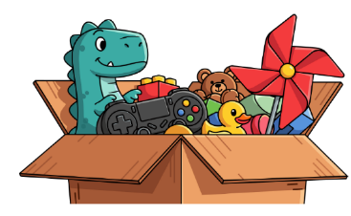
How have toys changed?

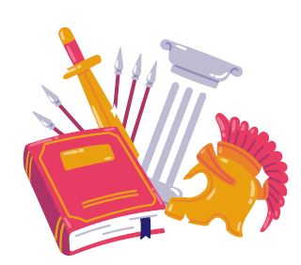
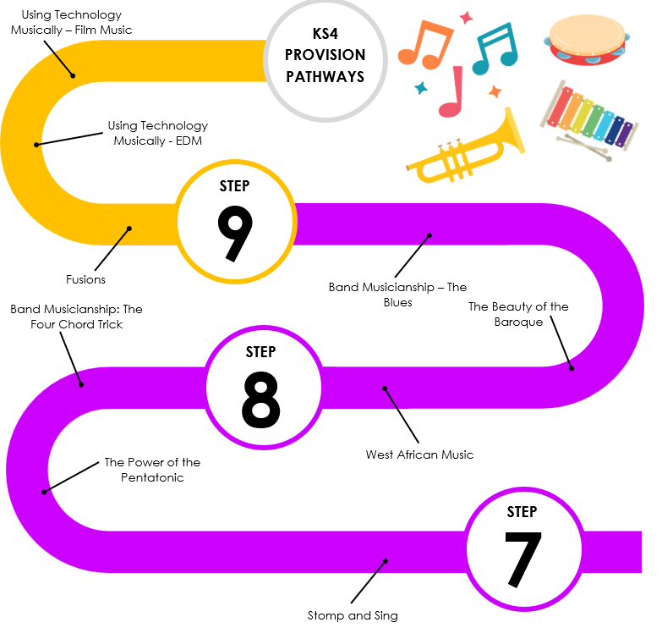
Yellowbellies’ and Events
Holocaust
Conflict in the 20th Century
Migration
Religion in Medieval England
The
Slave
Trade
The Black
Death
Getting the Vote
Middle East
Industrial Revolution
Developing the British Empire and America
English Civil War
Frist World War
Changing Ideas 1660-1789
The Problems of Medieval Monarchs
Trampolining
Challenges to the Catholic Church
The Crusades

Pop Art
War and Conflict

Photo Opportunity
Pop Art
Freedom
Tribal Art
Urban Art
Architecture
The Norman Conquest

