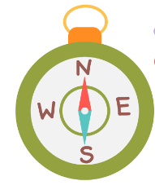
Can I carry out an independent fieldwork enquiry?
Why does population change?
STEP
6

STEP
1

STEP
2

STEP
4

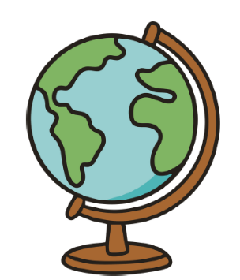
Where does our energy come from?
What is it like here?

STEP
5

Step
R

STEP
3

Step 1-9
Geography LTP
Why do Oceans matter?

Would you like to live in the desert?

What are rivers and how are they used?
What is life like in the Alps?
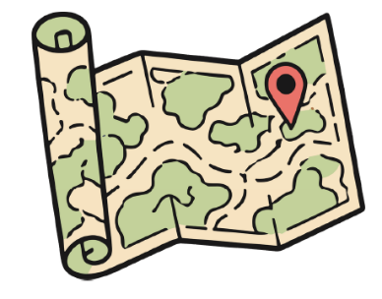
Why are rainforests important to us?

Where does our food come from?
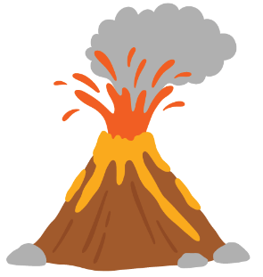
Are all settlements the same?

Who lives in Antarctica?

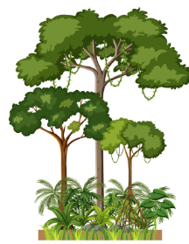
Why do people live near volcanoes?
What is it like to live by the coast?
Why is our world wonderful?

What is it like to live in Shanghai?
Would you prefer to live in a hot or cold place?
What is the weather like in the UK?

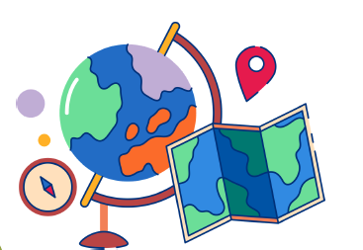
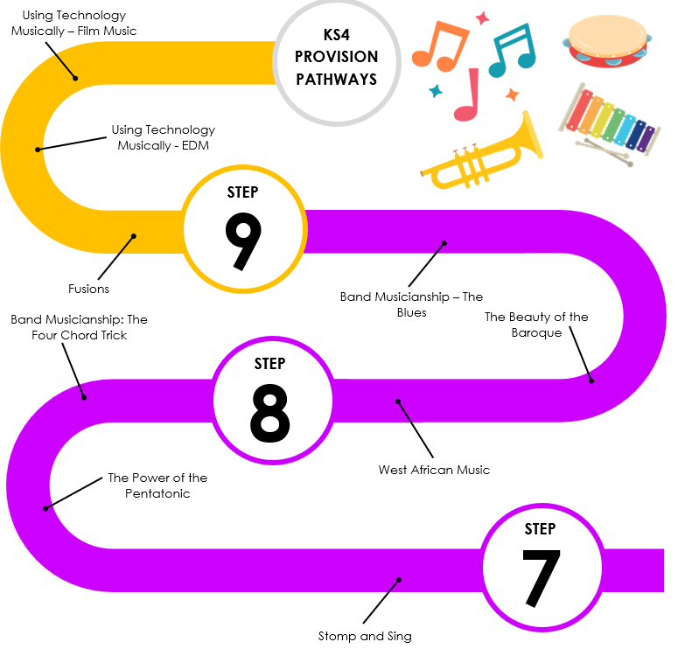
Human Geography Fieldwork Enquiry
How does ice change the world?
Can we ever know enough about Earthquakes and Volcanoes?
Why is the Middle East an important region?
What is the future for the planet?
What happens when the sea meets the land?
How are populations changing?
What is development?
Physical Geography Fieldwork Enquiry
Is the geography of Russia a curse or benefit?
What are the challenges facing Africa?
How is Asia being transformed?
How are populations changing - Leicester
What is weather and climate?
Trampolining
Why are rivers important?
What is an economy?
Is the Earth running out of natural resources?

Pop Art
War and Conflict

Photo Opportunity
Pop Art
Freedom
Tribal Art
Urban Art
Architecture
What is a Geographer?

