3D Modelling
Variables in Games
Introduction to Vector Graphics
Communication and Collaboration
STEP
6

STEP
1

STEP
2

STEP
4

Sensing Movement
Step 1-9
Computing LTP
Web Page Creation
Selection in Quizzes
Introduction to Spreadsheets
Data Logging
Photo Editing
The Internet
Desktop Publishing
IT Around Us

STEP
5

Step
R

STEP
3

Flat-File Databases
Repetition in Games
Video Production

Selection in Physical Computing

Systems and Searching
Repetition in Shapes

Events and Actions in Programs
Branching Databases


Audio Production

Sequencing Sounds

Connecting Computers
Programming Quizzes
Pictograms

Stop-Frame Animations
Digital Music
Robot Algorithms

Programming and Animations
Digital Photography
Grouping Data




Digital Writing
Moving A Robot

Digital Painting

Technology Around Us


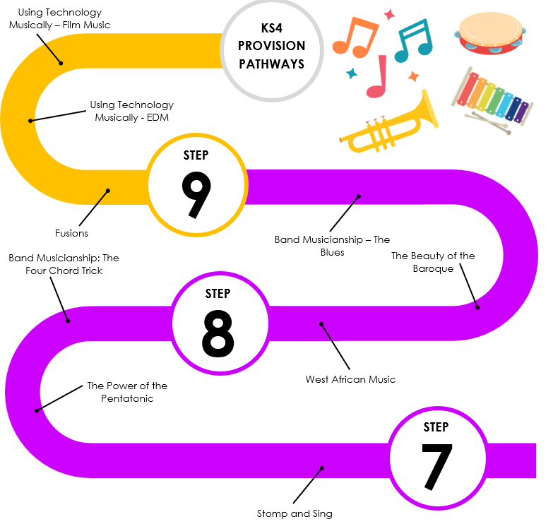
Applying Programming Skills with Physical Computing
Representations – Going Audiovisual
Data Science
Animations
Python Programming with Sequences of Data
Introduction to Python Programming
Representations from Clay to Silicon
Developing for the Web
Mobile App Development
Layers of Computing Systems
Using Media – Gaining Support for a Cause
Programming Essentials in Scratch – Part 2
Modelling Data using Spreadsheets
Programming Essentials in Scratch – Part 1
Networks from Semaphores to the Internet

Media – Vector Graphics
RATS!
Clear Messaging in Digital Media

