
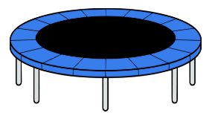
Athletics
Trampolining and Swimming
Athletics
Invasion Games (Football)
STEP
6

STEP
1

STEP
2

STEP
4

Striking and Fielding Games (Cricket)
Net and Wall Games (Tennis) and Swimming
Striking and Fielding (Rounders)
Invasion Games (Basketball)
Step 1-9
PE LTP
Net and Wall Games (Tennis)
Athletics
Athletics
Gymnastics and Dance
Gymnastics and Dance

STEP
5

Step
R

STEP
3

Net and Wall Games (Badminton) and Swimming
Invasion Games (Basketball)
Striking and Fielding Games (Cricket)

Trampolining and Swimming
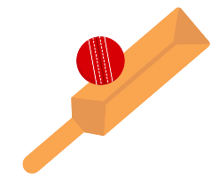

Invasion Games (Football)
Trampolining and Gymnastics
Invasion Games (Football) and Swimming
Striking and Fielding Games (Rounders)
Net and Wall Games (Badminton)

Swimming and Invasion Games (Netball)

Trampolining and Gymnastics
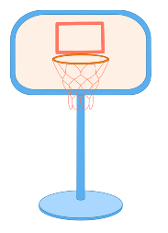
Invasion Games (Football) and Swimming
Hit, Catch and Run
Send and Return

Swimming and Invasion Games (Netball)
Run, Jump and Throw
Gymnastics and Dance

Hit, Catch and Run
Attack, Defend and Shoot
Send and Return



Run, Jump and Throw
Gymnastics and Dance
Attack, Defend and Shoot


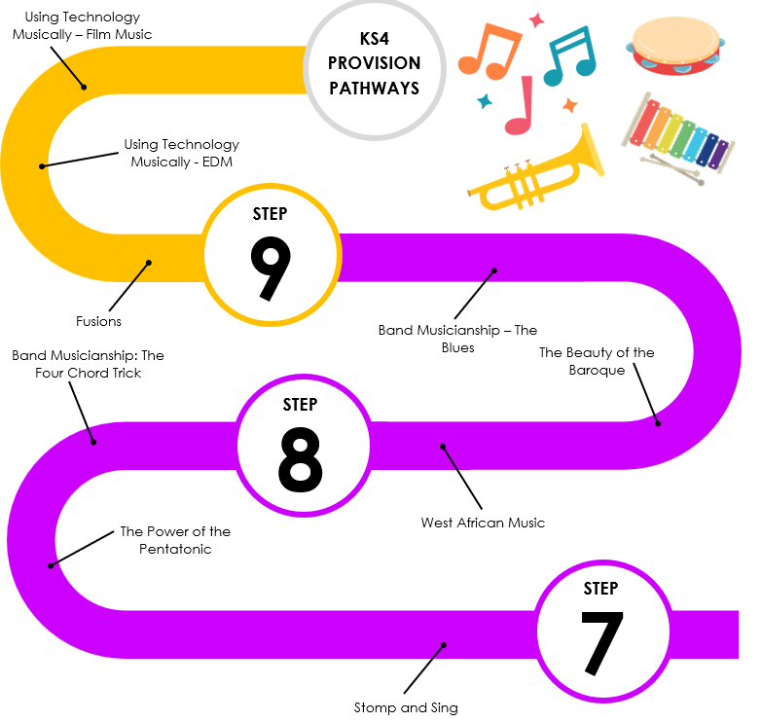
Sport Education (Striking and Fielding Games)
Invasion Games (Basketball and Lacrosse)
Striking and Fielding Games (Golf and Cricket)
Athletics
Athletics
Sport Education (Net and Wall Games)
Net and Ball Games (Table Tennis)
Net and Ball Games (Badminton)
Trampolining
Trampolining
Trampolining
Invasion Games (Netball and Hockey)
Health, Fitness and Physiology
Health, Fitness and Physiology
Athletics
Striking and Fielding Games (Cricket and Rounders)
Trampolining
Invasion Games (Handball and Tag Rugby)

Pop Art
War and Conflict

Photo Opportunity
Pop Art
Freedom
Tribal Art
Urban Art
Architecture
Health, Fitness and Physiology

