
Aboriginal Dreaming’s
Portraits: Identity and Technique
Artist Study
Interactive Installation
STEP
6

STEP
1

STEP
2

STEP
4

Aboriginal Dreaming’s
Portraits: Character and Meaning
Interactive Installation
Tapestry and Sewing
Step 1-9
Art LTP
Down in the Jungle
Mega Materials
Mega Materials
Power Prints
Festival Headdress
Abstract Shape and Space
Tell a Story
Make your Mark

STEP
5

Step
R

STEP
3

Day of the Dead
Rangoli

The
Explorer

I Need Space
Light and Dark
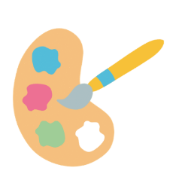

Landscapes

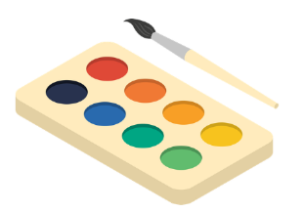

Prehistoric Art and Tomb Paintings
Prehistoric Art
Growing Artists
Inside the Rainforest
Flicker Book Movie

Roman Shield Design and Construction
Inside the Rainforest
Life in Colour

Treasure Maps
Greek Pottery
Picasso and Expression



Paper Play
Colour Splash

Introduction to Printing


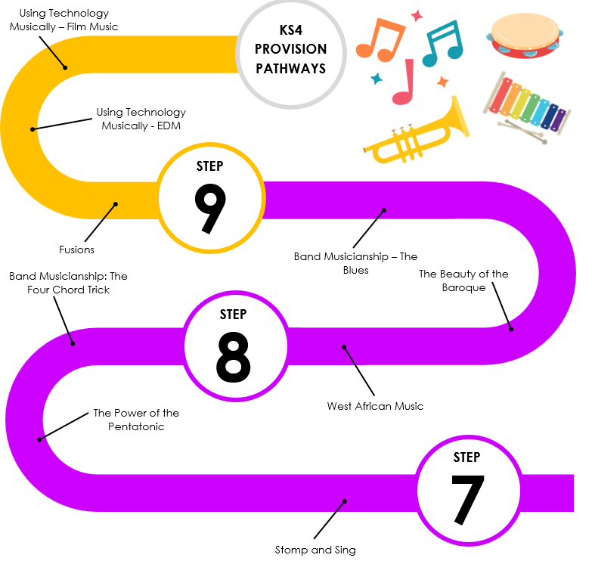

Pop Art
War and Conflict
Surrealism
Photo Opportunity
Pop Art
Freedom
Tribal Art
Urban Art
Architecture
Illustration
Mythical Creatures and Medieval Tapestry
RATS!
Every Picture Tells a Story

